The Menstrual Cycle and the role Oestrogen and progesterone
The menstrual cycle in women is a recurring process, taking around 28 days. During the process, the lining of the uterus - womb - is prepared for pregnancy, and if pregnancy does not happen, the lining is then shed at menstruation.
Several hormones control this cycle, which includes controlling the release of an egg each month from an ovary, and changing the thickness of the uterus lining. These hormones are secreted by the ovaries and pituitary gland.
FSH
The hormone FSH is secreted by the pituitary gland. FSH makes two things happen:
- it causes an egg to mature in an ovary
- it stimulates the ovaries to release the hormone oestrogen
Oestrogen
The hormone oestrogen is secreted by the ovaries. Oestrogen makes two things happen:
- it stops FSH being produced - so that only one egg matures in a cycle
- it stimulates the pituitary gland to release the hormone LH
LH
The hormone LH causes the mature egg to be released from the ovary.
Progesterone
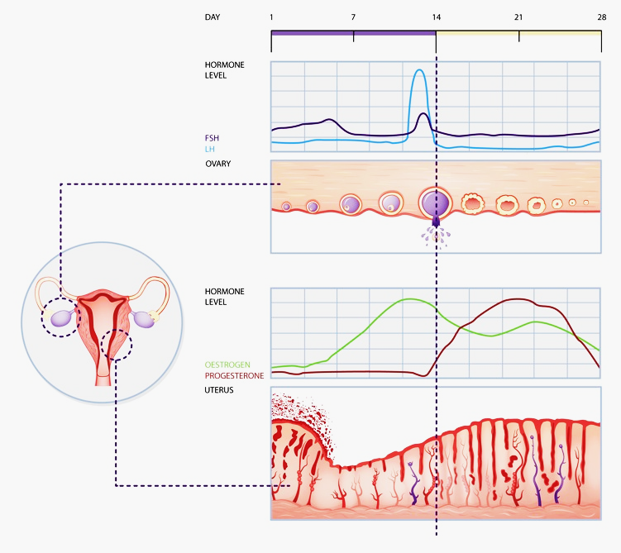
Progesterone is a hormone secreted by ovaries. It maintains the lining of the uterus during the middle part of the menstrual cycle and during pregnancy.
Menstrual cycle
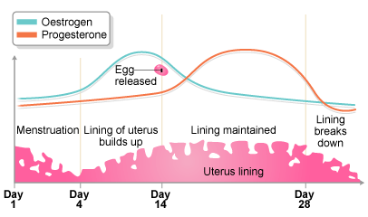
The two images below shows how the levels of oestrogen and progesterone change during the menstrual cycle.

